**Project report on**

**Raspberry-Pi powered Intelligent Driver Monitoring System for Detecting Drowsiness and Alert Generation to Prevent Accidents.**

Submitted by

**AYUSH KACHHAP (2241011004)**

**ANKIT KUMAR (2241011102)**

**INDERJEET SINGH (2241019691)**

**ASHUTOSH DASH (2241004149)**

**B. Tech. (CSE(IOT) 4th Semester (Section–2241009)**



**DEPARTMENT OF COMPUTER SCIENCE AND ENGINEERING**

Institute of Technical Education and Research

**SIKSHA ‘O’ ANUSANDHAN**

**DEEMED TO BE UNIVERSITY**

Bhubaneswar, Odisha, India.

(May, 2024)

# Abstract

# Contents

Abstract i

Contents ii

Chapter 01: Introduction 1

1.1. Introduction 1

1.2. Background 1

1.3. Project Objectives 1

1.4. Scope 1

1.5. Project Management 1

1.6. Overview and Benefits 2

1.7. Organization of the Report 2

Chapter 02: Background Review & Survey 3

2.1. Related Works 3

Chapter 03: Theoretical Aspects 4

3.1. Internet of Things (IoT) 4

3.2. Features of IoT 4

3.3. Advantages of IoT 4

3.4. Disadvantages of IoT 4

3.5. Application areas of IoT 4

3.6. IOT Technologies and Protocols 4

3.7. Project Layout 5

3.7.1. Brief Description 5

Chapter 04: Hardware Requirements 6

4.1. Arduino Uno 6

4.1.1. Features 6

4.1.2. Pin Configuration 6

4.2. ESP–01 6

4.3. Sensors 6

4.3.1. Pressure Sensor 6

4.3.2. Temperature Sensor 6

4.4. 6

4.5. Block diagram of the proposed system 6

4.5.1. Working of the system 6

4.5.2. Circuit Diagram 6

4.5.3. Components Required 6

Chapter 05: Software Requirements 8

5.1. Arduino IDE (Embedded C / C++) 8

5.2. Logic and Flowchart 8

Chapter 06: Project development & Testing Aspects 9

6.1. 9

Chapter 07: Conclusion & Future Scope 10

7.1. Result 10

7.2. Conclusion 10

7.3. Limitations 10

7.4. Further Enhancement and Future Scope 10

References 11

Appendix 01 12

A01.1. Code Listing 12

A01.2. Main Code 12

A01.3. Libraries 12

Appendix 02 13

A02.1. Project Proposal Form 13

A02.2. Project Management 13

A02.3. Bill of Material 13

Appendix 03 14

A03.1. Data Sheets 14

# Chapter 01: Introduction

## Introduction

## Background

## Project Objectives

## Scope

## Project Management

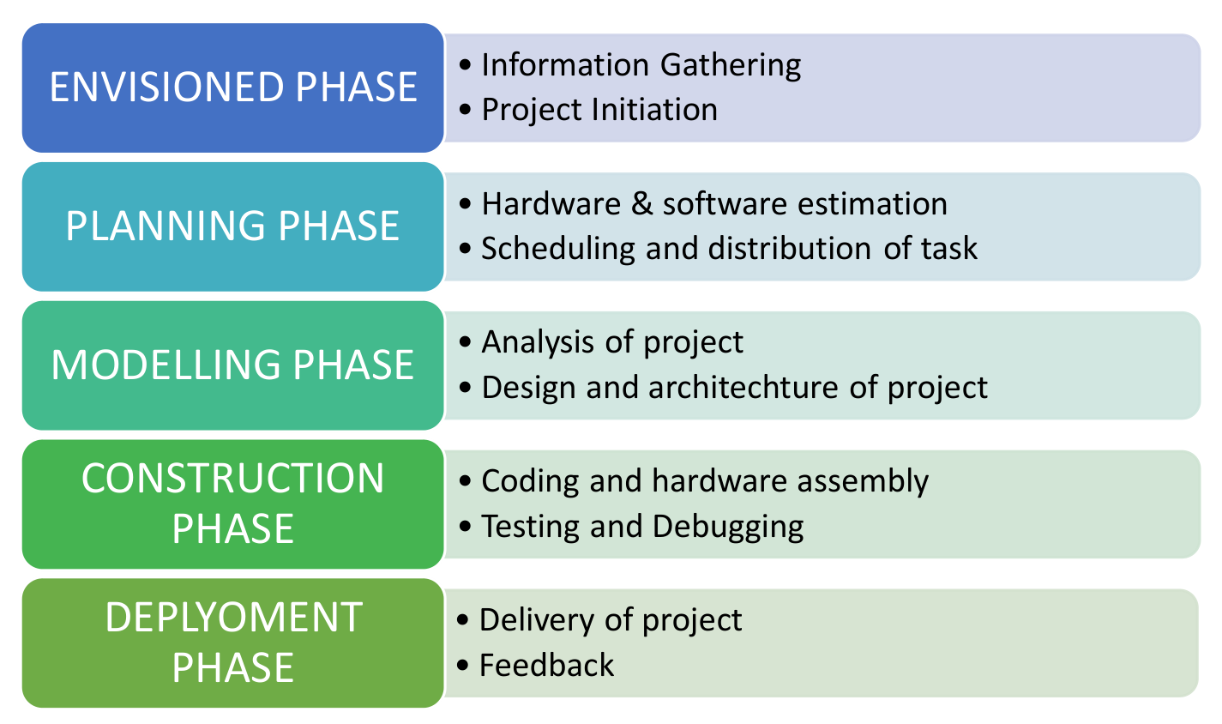

**Figure 1. Model of phases in project management.**

## Overview and Benefits

## Organization of the Report

The report is organised into the following chapters. Each chapter is unique on its own and is described with necessary theory to comprehend it.

Chapter 2 deals with background survey and review, Chapter 3 has the description of the theoretical aspects that has been acquired to commence the project work.

# Chapter 02: Background Review & Survey



## Related Works

# Chapter 03: Theoretical Aspects



## Internet of Things (IoT)

## Features of IoT

1. Intelligence
2. Connectivity
3. Dynamic Nature
4. Enormous Scale
5. Sensing
6. Heterogeneity
7. Security

## Advantages of IoT

1. Communication
2. Automation and Control
3. Information
4. Monitoring
5. Efficiency

## Disadvantages of IoT

1. Compatibility
2. Complexity
3. Privacy/Security
4. Safety

## Application areas of IoT

## IOT Technologies and Protocols

1. Bluetooth
2. Zigbee
3. Z-Wave
4. Wi-Fi
5. Cellular
6. NFC
7. LoRaWAN

## Project Layout

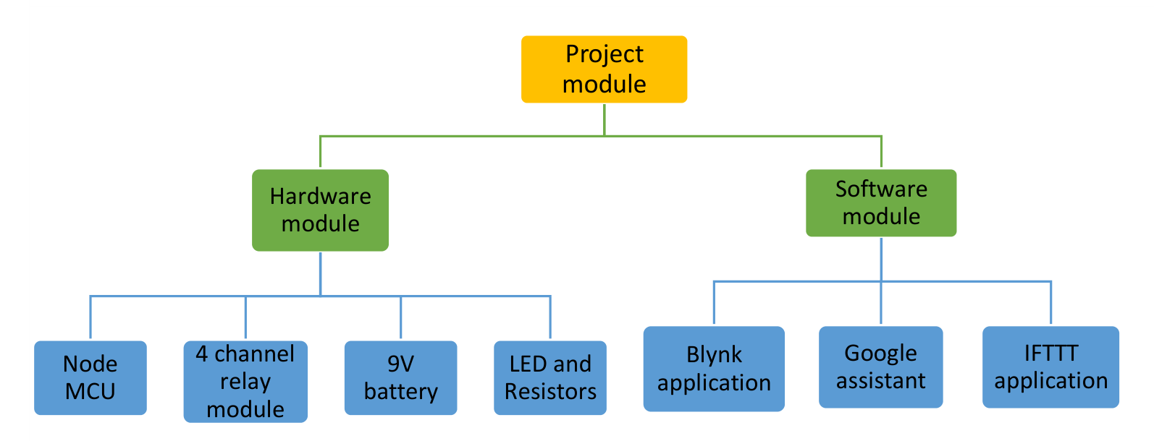

**Figure 2. Layout of project module**

### Brief Description

# Chapter 04: Hardware Requirements



## Arduino Uno

### Features

### Pin Configuration

## ESP–01

## Sensors

### Pressure Sensor

### Temperature Sensor

## 

## Block diagram of the proposed system

### Working of the system

### Circuit Diagram

### Components Required

**Table 1. Component listing.**

|  |  |  |
| --- | --- | --- |
| **Sl. No.** | **Component and Specification** | **Quantity** |
|  |  |  |
|  |  |  |
|  |  |  |
|  |  |  |
|  |  |  |
|  |  |  |
|  |  |  |

# Chapter 05: Software Requirements



## Arduino IDE (Embedded C / C++)

## Logic and Flowchart

# Chapter 06: Project development & Testing Aspects



## 

# Chapter 07: Conclusion & Future Scope



## Result

## Conclusion

## Limitations

## Further Enhancement and Future Scope

# References

# Appendix 01

## A01.1. Code Listing

## A01.2. Main Code

## A01.3. Libraries

# Appendix 02

## A02.1. Project Proposal Form

The project proposal form was prepared and duly signed from our Faculty-in-Charge Dr. Biswaranjan Swain. The same is attached at the last of this report.

## A02.2. Project Management

|  |  |  |  |  |
| --- | --- | --- | --- | --- |
| **#** | **Component** | **Individual Contributions in %** | | **Total** |
| **Name 01** | **Name 02** |  |
|  | Planning |  |  |  |
|  | Background Research and Analysis |  |  |  |
|  | Hardware design |  |  |  |
|  | Software design |  |  |  |
|  | Testing |  |  |  |
|  | Final Assembling |  |  |  |
|  | Project report writing |  |  |  |
|  | Presentation |  |  |  |
|  | Logistics |  |  |  |
|  |  |  |  |  |
|  |  |  |  |  |
|  |  |  |  |  |

## A02.3. Bill of Material

**Table 1. Component listing.**

|  |  |  |  |  |  |
| --- | --- | --- | --- | --- | --- |
| **#** | **Component** | **Specification** | **Unit Cost** | **Quantity** | **Total** |
|  |  |  |  |  |  |
|  |  |  |  |  |  |
|  |  |  |  |  |  |
|  |  |  |  |  |  |
|  |  |  |  |  |  |
|  |  |  |  |  |  |
|  |  |  |  |  |  |
|  |  |  |  |  |  |
| **Grand Total** | | | | |  |

# Appendix 03

## A03.1. Data Sheets